# Getting Started With ScriptEase II

The goal of this tutorial is to build on the last tutorial, Making Your World, by using ScriptEase II to flesh out the world and making it more compelling. We will use the world you created in the last tutorial, so make sure you have completed it.

First we will make some text appear when we interact with the pirate flag, then add a conversation to our Captain, and finally cause him to react to the player’s responses to the conversation. All of these events require scripts, or pieces of code, to happen. But instead of writing code, we will use ScriptEase II to generate the scripts for you.

By the end of this tutorial, you will have a basic understanding of generating scripts for your game with Scriptease II and how to create conversations in Aurora.

## Getting Started:

1. Go to your Neverwinter Nights directory. If you haven’t done so, create a backup of TreasureIsland.mod by copying it and pasting the copy somewhere safe. Now, if you somehow destroy your module, you can always load up the previous.
2. Close the Aurora Toolset if it is open. You cannot open a module in ScriptEase II if it is also open in the Aurora Toolset. This is to prevent one program from overwriting the changes made in another while you are working.
3. Open ScriptEase II by double-clicking the “ScriptEase.jar” file or the icon on your desktop.
4. Create a new Story from the File menu. Name your story “Treasure Island”, enter your name in the Author field, and write “A tale of mutiny and treasure” in the description.
5. Select “Neverwinter Nights” in the “Game” box and then browse to the “Treasure Island.mod” module under the “modules” folder. Click finish when you are done.

Tip:The Description and Author are only used by developers; they are not visible to players.

1. ScriptEase II will now load your module (Figure 1).

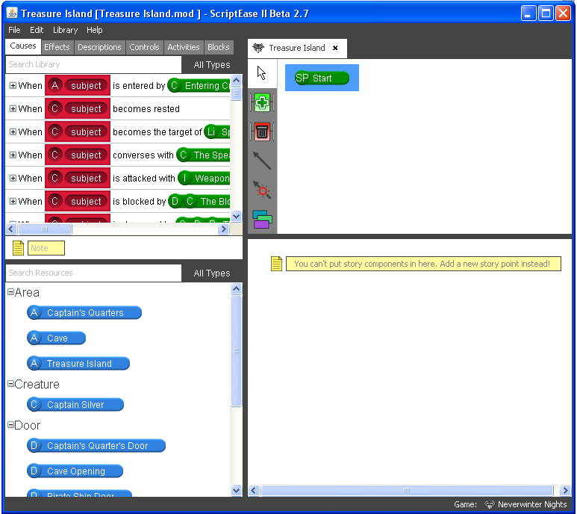

Figure

1. The left side contains all of the assets you can add to your story. The top part is the Library pane, which contains causes and effects that you can add to your story to make things happen. The middle section is the Note pane. Notes can be added to the story as textual reminders and comments for yourself without affecting your story. Underneath this is the Resource pane. It contains all assets in your module that can be dragged into causes and effects.

Tip:Remember creating blueprints for important objects in the previous tutorial? Only objects with blueprints are shown in the Resource pane.

1. The right side represents your game’s story. The story graph on top is used to create a basic overview of your story using Story Points. Underneath the graph is the Story Point pane. This pane represents what is inside of the currently selected Story Point. This is where you drag in your causes and effects.

Tip:Double click the active tab to change the name of the story.

Now that we have the basics down, let’s get started!

Tip:Notice that the story is in a tab. You can open multiple stories in ScriptEase II, with one tab per story.

## Scripting Game Objects with Causes and Effects:

1. Let’s start by adding a Story Point to the start Story Point. Click the Add icon  on the toolbar beside the start Story Point and then click on the start Story Point to add a new Story Point. Rename the “New Story Point” to “Treasure Island” (Figure 2).



Figure

1. Use the selection tool  to select the “Treasure Island” Story Point to access its contents. There is nothing inside right now.
2. Let’s give the player some context to the story when they click on the pirate flag. We need to find the cause called “When subject is used by last user”. ScriptEase II has a lot of causes, so let’s find it by searching for the word “used” in the search box in the Library pane at the top left corner.
3. Make sure you have the “Treasure Island” Story Point selected, then drag the “When subject is used by last user” cause into the Story Point pane on the bottom right of ScriptEase II (Figure 3). You will notice that it contains a component called “Current Active describes if current story point is active”. Components with the word “describes” are called descriptions, which we will cover later. Below the description is a question component called “Current Active” with Yes and No parts. There will be more on this later, too.   
     
   What’s important to know for now is that every cause contains these components. Any effects dragged into the Yes part only occur when the cause’s story point is active. Likewise, any effects in the No part will only happen when the story point is inactive. Any effects dragged outside of these two parts will happen regardless of which story point is active. The story points after the start story point are always active by default. Succeeding it, which makes it inactive, will be discussed more in depth later as well.

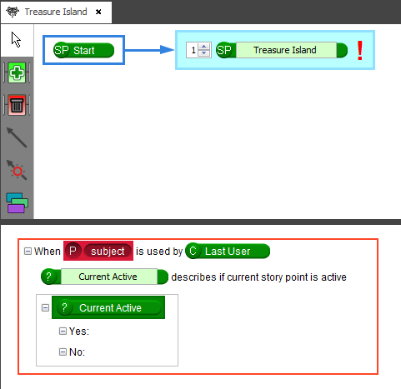

Figure

Tip:You can search in the Resource pane just like in the Library pane.

1. When you save, if you have errors in your story ScriptEase will give you a warning message. In this case we have not added anything to the subject slot in our cause, so ScriptEase will generate the following warning: “Slot ‘subject’ is empty in the “When <subject> is used by <last user” as well as a red exclamation mark in the story point. To fix this find the Pirate Flag in the Resource pane below the Library. Once you find it, drag the blue Resource into the subject slot inside the cause.
2. We now have a complete cause. But it doesn’t do anything until we add effects! Click the “Effects” tab in the Library pane and search for “speaks”. Drag the “Subject speaks Text at Talk Volume” effect directly into the cause, above “Current Active”.
3. Write “All hail the new Captain of the Hispaniola!” or something similar in the text box of the effect. Leave the volume box alone (Figure 4).

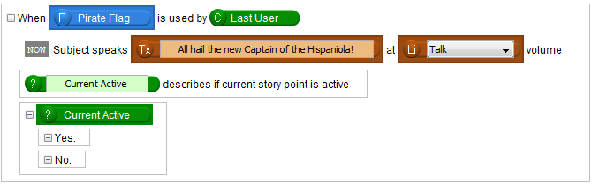

Figure

1. Save your story by going to “File” 🡪 “Save” in the menu. You can save this SE2 story file anywhere. Saving will add the scripts to your module and compile it for you. Let’s test it out by pressing F9, just like in Aurora. Start up the game and click on the pirate flag to see the text appear.

Tip:If you encounter any problems with saving or testing the story, please refer to the ScriptEase II instructions.

1. You have added your first script to the game! Let’s add some more scripts to progress the story.

## Adding Conversations:

1. After making sure you have saved your story, close the story in ScriptEase II. You can do so by closing the tab that says Treasure Island (Treasure Isand.mod). Open the module in Aurora. If you look in the “Scripts” category in the assets view, you will notice that ScriptEase II added a few scripts.   
     
   You could make changes to these scripts, but ScriptEase II will discard them the next time you save the module with it. If you want to write your own scripts manually, make sure that they do not start with “se_”.
2. Let’s add a conversation to our game. Right click on “Conversations” in the asset view on the left and click “New”. The “Conversation Editor” will open up. Right click on “Root” and click on “Add”. In the box that pops up, write “<FirstName>! I forgot me rum on board the Hispaniola. Be a good <lad/lass> and get it for me!” (without the quotes), and Click Ok.



Tip:You probably noticed that <FirstName> and <lad/lass> look different than the rest of the text. These are “Tokens” that show special text based on the converser. For example, <lad/lass> will automatically be replaced with “lad” if the character is male or vice versa if they are female. You can see a list of all of these tokens in the “Conversation Editor” by clicking on

1. Conversations in Aurora follow a tree structure. All conversations start with a root. Branches from that root express any further dialogue. To add some player responses, right click the conversation node you just added and click “Add” again. Type in “Alright, be right back.” and click “Ok”.
2. The player might not want to fetch the rum, so let’s add another response in the same way. This time, give it the text, “Get your own!” Your conversation should look like the screenshot below.



1. Save the conversation and name it “captain_convo”.
2. Since this is the first node in the “Root”, this conversation automatically plays when we speak with the Captain. We need to add another conversation node to this conversation that will play after we agree to fetch the rum. Add one onto “Root” with the text “Your back! But where is me rum?”
3. Add a player response with the text, “I was just about to get it.”
4. You can add another response from the Captain to this in the same way. Add another line after “I was just about to get it” and give it the text, “Well, get a move on! I’m thirsty!” Make sure your conversation looks exactly like the screenshot below:

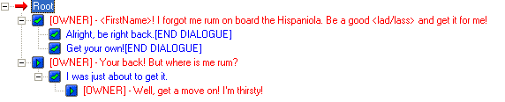

1. We want to be able to decline at this point, too. Instead of writing the same thing as in the previous conversation node, right click the “Get your own!” node and click copy. Right click the “Your back!” node and click “Paste as Link”. This creates a link, meaning the same text will be shown and the same scripts will be fired.
2. Add one more conversation path to the “Root” node to match the screenshot below. Once you are done, save the conversation again and close the Conversation Editor.

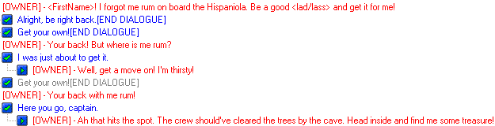

1. The conversation needs to be attached to the Captain. Open up the Treasure Island area, and then find Captain Silver in the palette on the right. This will be in “ Creatures” 🡪 “Custom” 🡪 “NPCS” 🡪 “Humans”. Make sure you have selected the “Custom” filter instead of “Standard”. Right click Captain Silver and click on “Edit”.
2. Click on the triangle button beside the “Conversation” drop down box and select “captain_convo”. Press “Ok” once you have done so.
3. We have added the conversation to the Captain’s blueprint in the palette, but the Captain we have placed in the area story was created from the old blueprint. Objects placed in areas are created from blueprints and do not automatically update, so he does not have the conversation attached yet.

Tip:Objects created from blueprints are called “instances” in the Aurora Toolset.

1. To update the Captain, right click Captain Silver in the palette and click on “Update Instances”. Click on “Yes” for the first dialog and then “No” on the second to update all Captain Silvers. This also works for updating appearances, tags, or anything else.
2. Save your module and test it by pressing F9. Try speaking with the Captain. You will notice that only the first conversation path is played! This is because you need to add scripts to disable a previous conversation node in order to move onto the next one. Let’s use ScriptEase II to do that. Close Aurora and open your story in ScriptEase II again. You need to remember where you saved the SE2 story file, which is not the same as the module file you opened in Aurora.

## Scripting Conversations:

1. Notice that a few new Game Objects have appeared under the “Dialogue” category in the Game Object pane, one for each of the lines we added. We will be using these in this section.
2. Let’s add another Cause to our story. This time, we will add the “When subject is reached” cause. Find it and drag it under the previous cause inside the only story point.
3. This cause takes a dialogue line as a parameter. Expand “captain_convo” and “<FirstName>!...” then drag the “Alright be right back” dialogue line to the subject.
4. Instead of adding our effects directly in the cause we will be adding them to the Yes section of the “Current Active” question. Effects in the yes section of “Current Active” will only happen when the Story Point is active. The “Treasure Island” Story Point that we are in is active by default, so anything we add in here will happen when the dialogue line is reached as long as we have not passed this point in the story.
5. The Captain’s rum is inside the Captain’s Quarters, but they are locked by default. In effects, search “unlock”, and drag in the effect “Set the object to Unlocked” to the Yes section. Drag the Captain’s Quarter’s Door resource into the Object slot.
6. We also want to change what the Captains says when we reach this point. More specifically, we want him to say his next line. All conversation nodes are enabled by default, so all we have to do is disable the node we just finished with. Drag in the effect called “Disable dialogue line” to the same Yes section of the “Current Active” question. Drag the line beginning with “<First Name>! I forgot…” into the slot (Figure 5).

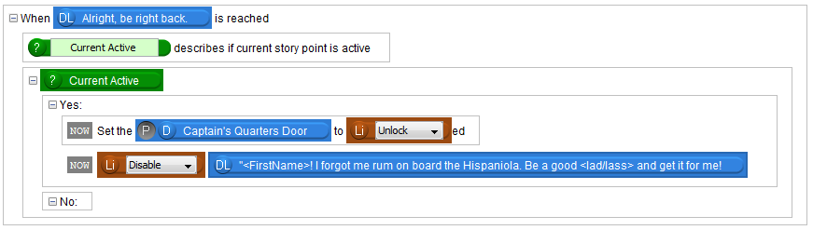

Figure

Tip:Notice that the link we created to the other node is light blue. Conversation links in NWN can be disabled and enabled independently of the original node. However, using the dialogue line in a “When dialogue line is reached” cause will fire the cause when either the original or the link is reached.

1. Save and test your story by pressing F9. Make sure the door unlocks and that the Captain changes his conversation when you talk to him again.

## Descriptions:

1. That works, but I doubt the Captain would just stand by when you disobey him. Let’s give him a proper response. Add another “When dialogue line is reached” cause to the story point, and drag in the “Get your own!” dialogue line as the subject.
2. Let’s make the Captain yell at the player. Drag an effect called “Speaker speaks text at talk volume” directly into the cause (above “Current Active”). This is similar to the previous effect we dragged into the Pirate Flag’s cause, except we can specify the speaker.

Tip:We don’t use the previous effect because the subject would be the dialogue line; dialogue lines do not speak, they are spoken.

1. Drag in “Captain Silver” to the speaker slot, and write “You’ll die for your insolence!” in the text field. Change “Talk” to “Shout”.
2. We’ve made the pirate say that the player will die, but he won’t live up to his word unless we script him to. Drag in an effect called “Attacker attacks Target” into the cause. In this case, the Attacker is Captain Silver. As a shortcut, you can drag the Captain Silver object from the previous line into this one.

Tip: **Descriptions** are used to access game objects that can only be resolved during gameplay. For example, the nearest door to another object depends on where the object currently is when you play the game.

1. We still need a target. If you check the game objects, you will notice that the player is not listed there. Players are not physical entities in our module until we play the game, so we need another way to add them to our story. This is where Descriptions come into use.
2. Click the Descriptions tab at the top left corner. In this case, we need to find “The Player Character describes The Player Character” description and drag it in between the two effects. **It needs to come before the effect that will use it or else we will not be able to drag the player character into the effect; order matters.**
3. Drag the newly created Player Character object into the Target slot.
4. Reorganize any effects if they have fallen out of order and rebind any slots that have become unbound. You can also disable the “Current Active” description and question since we won’t be using it for this cause by selecting them and pressing Ctrl + E (Figure 6). Disabled lines will do nothing to the game. You can simply delete “Current Active”, but disabling it allows you to quickly get them back (by pressing Ctrl + E again) if you ever want to use them again in the future.

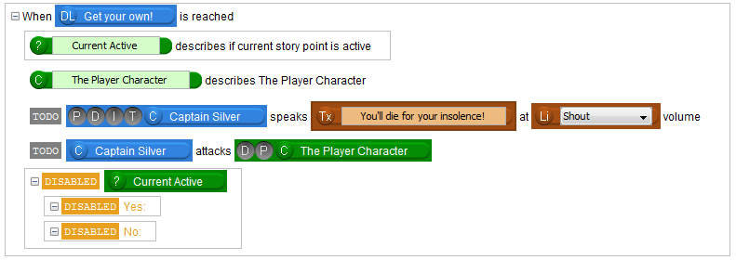

Figure

1. Save and test your story again. The captain should now kill the player when they disobey orders. This will also work in the other conversation, where we linked the text.

## Activities:

1. Suppose Captain Silver had some amazing gear that he didn’t equip yet before attacking the player. We could drag in two more effects to make Captain Silver equip his best equipment before the “Attacker attacks Target” effect, but there is already something that does that for us. We call these Activities. Click the “Activities” tab, where the “Causes” and “Effects” tabs are. Activities are essentially a container with a bunch of prepopulated effects so you don’t have to drag in 3 effects every time you want to perform these series of effects.
2. Start by deleting the “Attacker attacks Target” effect and drag in the Activity “Attacker equips its best gear and attacks Target”.
3. You will notice there are purple bindings already occupying some of the effect slots, namely “Attacker” and “Target”. This means that anything that gets dragged into the “Attacker” slot in the Activity will correspond to the Attacker purple binding. Similarly, anything dragged into the “Target” slot in the Activity will correspond to the Target purple binding. If you don’t like them you can replace them with other Game Objects as we have done before.
4. Drag “Captain Silver” to the “Attacker” slot in the Activity we just dragged in and “The Player Character” into the “Target” slot (Figure 7). Now Captain Silver will equip his best gear (if he has any) before attacking our player!

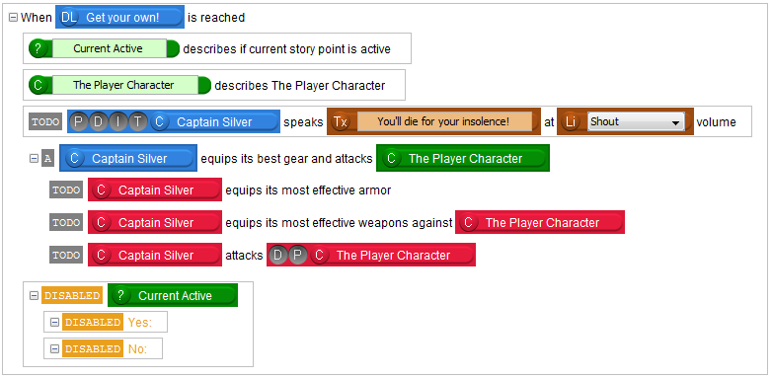

Figure

Good job, you’ve finished the second tutorial! Your world is more alive now, and you have added the first step of the story.

You might notice that ScriptEase II saves and reads from a separate *.ses file. This file remembers all of the causes, effects, and other story components you have added to a story. It is also linked to the module. Therefore, this file is just as important as the module to work on your story. Keep backups of this, too! However, the file is not necessary to play your module, so do not include it in the final release to the public.

In the next tutorial, we will continue our story using Story Points and the story graph.